PIZZAHUT SALE ANALYSIS

**SQL QUERIES:**

1. **Retrieve the total number of orders placed.**

SELECT COUNT(order_id) AS Total_Orders

FROM orders;



1. **Calculate the total revenue generated from pizza sales.**

SELECT ROUND(SUM(pizzas.price * order_details.quantity),2) AS Total_Revenue

FROM pizzas JOIN order_details

ON pizzas.pizza_id = order_details.pizza_id;

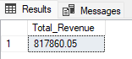

1. **Identify the highest-priced pizza.**

SELECT TOP 1 pizza_types.name, ROUND(pizzas.price,2) AS price

FROM pizza_types JOIN pizzas

ON pizza_types.pizza_type_id = pizzas.pizza_type_id

ORDER BY pizzas.price DESC;

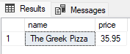

1. **Identify the most common pizza size ordered.**

SELECT TOP 1 pizzas.size, COUNT(order_details.order_details_id) AS order_count

FROM pizzas JOIN order_details

ON pizzas.pizza_id = order_details.pizza_id

GROUP BY pizzas.size

ORDER BY order_count DESC;

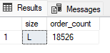

1. **List the top 5 most ordered pizza types along with their quantities.**

SELECT TOP 5 pizza_types.name, SUM(order_details.quantity) AS quantities

FROM pizza_types JOIN pizzas

ON pizza_types.pizza_type_id = pizzas.pizza_type_id

JOIN order_details

ON pizzas.pizza_id = order_details.pizza_id

GROUP BY pizza_types.name

ORDER BY quantities DESC;

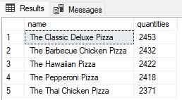

1. **Join the necessary tables to find the total quantity of each pizza category ordered.**

SELECT pizza_types.category, SUM(order_details.quantity) AS total_quantity

FROM pizza_types JOIN pizzas

ON pizza_types.pizza_type_id = pizzas.pizza_type_id

JOIN order_details

ON pizzas.pizza_id = order_details.pizza_id

GROUP BY pizza_types.category

ORDER BY total_quantity DESC;

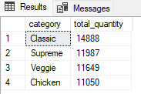

1. **Determine the distribution of orders by hour of the day.**

SELECT order_hour,COUNT(order_id) AS no_of_orders

FROM (

SELECT DATEPART(HOUR, time) AS order_hour, order_id

from orders

) AS hourly_order

GROUP BY order_hour

ORDER BY order_hour;

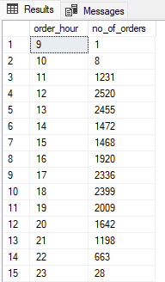

1. **Join relevant tables to find the category-wise distribution of pizzas.**

SELECT pizza_types.category, COUNT(pizzas.pizza_id) no_of_items

FROM pizza_types Join pizzas

On pizza_types.pizza_type_id = pizzas.pizza_type_id

GROUP BY pizza_types.category

ORDER BY no_of_items DESC;

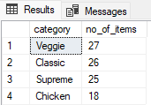

1. **Group the orders by date and calculate the average number of pizzas ordered per day.**

SELECT ROUND(AVG(total_order),0) AS avg_order_per_day

FROM

(

SELECT orders.date, SUM(order_details.quantity) AS total_order

FROM orders JOIN order_details

ON orders.order_id = order_details.order_id

GROUP BY orders.date

) AS daily_orders;

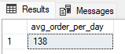

1. **Determine the top 3 most ordered pizza types based on revenue.**

SELECT TOP 3 pizza_types.name AS pizza_type,

ROUND(SUM(pizzas.price * order_details.quantity),2) AS revenue

FROM pizza_types JOIN pizzas

ON pizza_types.pizza_type_id = pizzas.pizza_type_id

JOIN order_details

ON pizzas.pizza_id = order_details.pizza_id

GROUP BY pizza_types.name

ORDER BY revenue DESC;

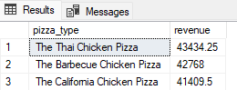

1. **Calculate the percentage contribution of each pizza type to total revenue.**

SELECT pizza_types.name AS pizza_type,

ROUND(SUM(pizzas.price * order_details.quantity),2) AS revenue_per_pizza_type,

ROUND((SUM(pizzas.price * order_details.quantity) * 100 /

(SELECT SUM(pizzas.price * order_details.quantity)

FROM pizzas JOIN order_details

ON pizzas.pizza_id = order_details.pizza_id)),2) AS percentage_contribution

FROM pizza_types JOIN pizzas

ON pizza_types.pizza_type_id = pizzas.pizza_type_id

JOIN order_details

ON pizzas.pizza_id = order_details.pizza_id

GROUP BY pizza_types.name

ORDER BY percentage_contribution DESC;

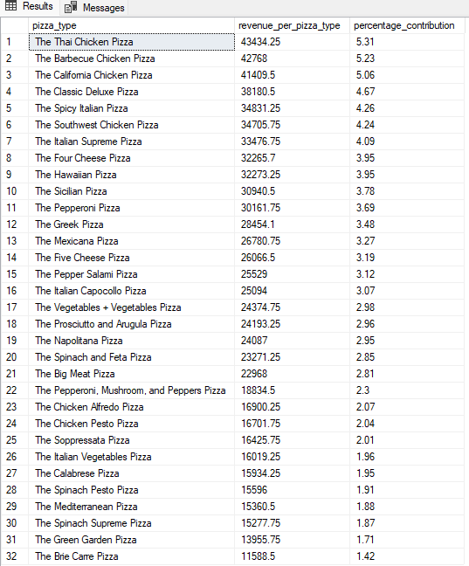

1. **Analyze the cumulative revenue generated over time.**

SELECT date,

revenue,

ROUND(SUM(revenue) OVER (ORDER BY date),2) AS cumulative_revenue

FROM

(SELECT orders.date, ROUND(SUM(pizzas.price * order_details.quantity),2) AS revenue

FROM orders JOIN order_details

ON orders.order_id = order_details.order_id

JOIN pizzas

ON order_details.pizza_id = pizzas.pizza_id

GROUP BY orders.date) AS revenue_per_day;

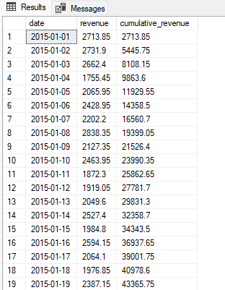

1. **Determine the top 3 most ordered pizza types based on revenue for each pizza category.**

WITH pizza_revenue AS (

SELECT pizza_types.category, pizza_types.name,

COUNT(order_details.quantity) AS total_orders,

ROUND(SUM(pizzas.price * order_details.quantity),2) AS total_revenue,

RANK() OVER(PARTITION BY pizza_types.category ORDER BY SUM(pizzas.price * order_details.quantity) DESC) AS rank

FROM pizza_types JOIN pizzas

ON pizza_types.pizza_type_id = pizzas.pizza_type_id

JOIN order_details

ON pizzas.pizza_id = order_details.pizza_id

GROUP BY pizza_types.category, pizza_types.name

)

SELECT category, name,total_orders, total_revenue

FROM pizza_revenue

WHERE rank <= 3

ORDER BY category, total_revenue DESC;

